Easter Season – Gospel Acclamations
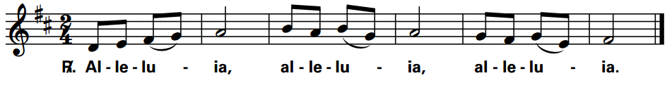
(Gospel acclamation may be transposed to fit with verses)
Divine Mercy Sunday, April 7
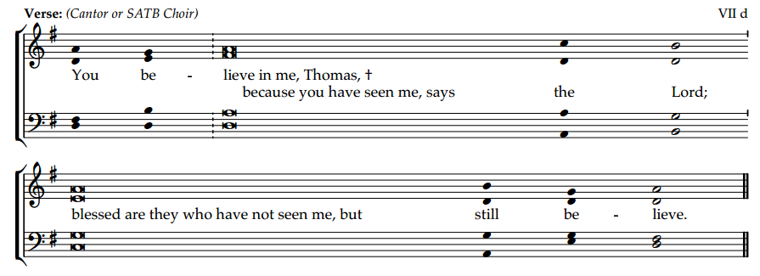

Easter 3, April 14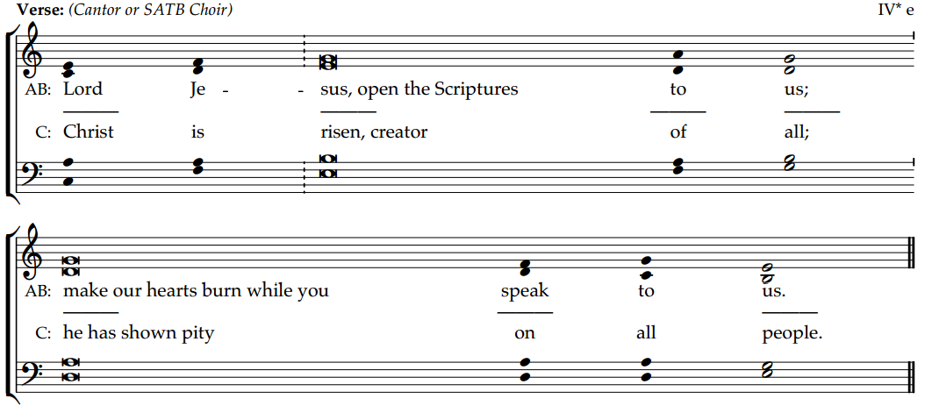

Easter 4, April 21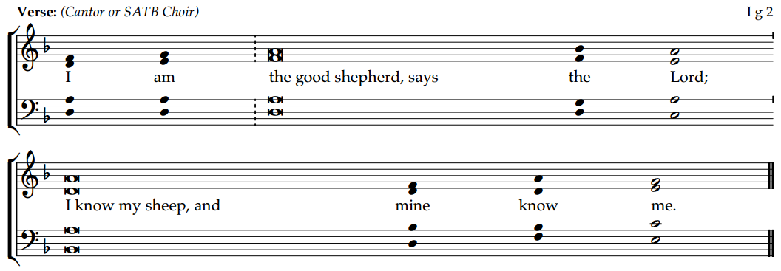

Easter 5, April 28